Automatic Packing List

The project

Introduction

GMA Accessories is a whole sale manufacturing/importing company. GMA Accessories main products are variety of fashion accessories styles, which are being sold to many customers in a way that varies from one customer to another. The dimensions of these styles also vary from one item to another. Due to these factors, the way that GMA packs the styles into cartons before shipping to the customer is a very important, complicated and time consuming process.

Actual Situation:

Currently, GMA is using the Manual Packing List program in Aria to assign the component and weight of each carton. This process is usually need to be done for one store at the time in case of shipping multi-store orders that contain hundreds of stores in most of the cases. This process has been encountered with the following problems:
- Very time consuming process where the time factor is very important for the shipping process.
- Subject to human errors such as putting the wrong component or quantities into improper cartons.
- No control or link between the physical packing process and the Packing List as a document entered on the computer system.
- Delaying the UCC labels printout and consequently generating of the ASN which are dependent processes on the Packing List.

This chart illustrates the shipping cycle and the Packing List role:

S/O processing
Packing List processing
UCC 128
Labels
Generate ASN
Invoicing
S/O
Bill of Lading processing

* Highlighted processes only are involved in this project research.

Types of Multi-Store Orders Scenarios:

After analyzing the different scenarios that involve the Packing List process for multi-store orders, it has been found that these cases apply:

- All styles allocated to each Store are packed into one carton:
- The Pieces and Weight are similar for all stores/cartons
- The Pieces and Weight vary by each store/carton

- Combination of Styles are packed into the same carton:
- One Pattern is used within the same sales order where the selected styles are packed into one carton and the same quantity ordered for all stores.
- One Pattern is used within the sales order where the selected styles are packed into one carton but the quantity varies from store to store.

- Pre-defined Qty by customer for each Style to be packed into one carton (Qty/Carton). Number of cartons may vary from store to store, based on ordered quantity.

- Pre-defined number of Packs to be packed in one carton (Packs/Carton). Each Pack usually contains a combination of styles or colors.

Project Goal:

The project will focus on the following goals:
- To speed up the Packing List processing for huge multi store orders
- To reduce Packing errors related to component or quantity per carton
- To control the Packing List comparing with the Sales order
- To save some important information related to the Carton’s dimensions required by each customer.

Limitation of the Project:

The Project is involved mainly in optimizing the Packing List processing. However, due to the variety of customers and consequently the way that GMA is required to pack the goods, the Manual Packing List will still be used to cover some cases that cannot be handled by the Automatic Packing List such as:
- No specific pattern to pack the styles for the different stores in the same order.
- Different Qty/Carton for the same style in the different stores.
- Each store orders different styles in the same sales order.

Other Limitations:
- The project does not affect or enhance the Manual Packing List.
- The project does not affect or enhance SO, UCC Labels, ASN or Invoice.
- The project will affect the way we assign the Packing list(s) to Bill of Lading.
- The project will not force or control the physical packing process against the P/L document in Aria.

Solutions:

After analyzing the actual situation and the different scenarios of the Packing List, it has been found that below solutions are covering most of the cases:

- Setup the Packing Info (Qty/Carton and Weight/Unit) on the Style & Customer level. The Packing info will be carried over to the sales order level and allow the user to change it based on each case. This info will be used to create the Packing List for the sales orders belonging to each customer. This solution will help in these cases:
- Pre-defined Qty by customer for each Style to be packed into one carton (Qty/Carton). Number of cartons may vary by store based on the ordered quantity.
- Pre-defined number of Packs to be packed in one carton (Packs/Carton), Each Pack usually contains a combination of styles/colors.

- Create a Packing List Template; This “Template” will be updated on the sales order level in general (but not for each store individually) to design a Packing List pattern. This pattern can be used to generate the Packing List automatically for each store on the order. This solution will help in these cases:

- All the styles ordered for each Store are packed into one carton:
- The Pieces and Weight are similar for all stores/cartons
- The Pieces and Weight vary by each store/carton

- Combination of Styles are packed into the same carton:
- One Pattern is used within the same sales order where the selected styles are packed into one carton and the same quantity ordered for all stores.
- One Pattern is used within the sales order where the selected styles are packed into one carton but the quantity ordered varies by store.

Note:

Both solutions will be integrated to achieve the end goal of optimizing the Packing List processing in Aria.

In the following paragraphs, details of each solution are described.

Setup the Packing info on the Style & Customer level:

In this solution, the Carton information for each Style or Pack Id will be updated on Customer level. The vital info, such as Qty per Carton and Unit Weight, will be defined per each Customer/Style (or Pack Id) to be carried over to the order level to help creating the Packing List automatically for this customer.

Select Style/Color

Select Customer(s)
Packing Info.

Select
Pack Id

A new table and screen option will be designed to update this info through the Style screen in Aria:
Customer Packing Info
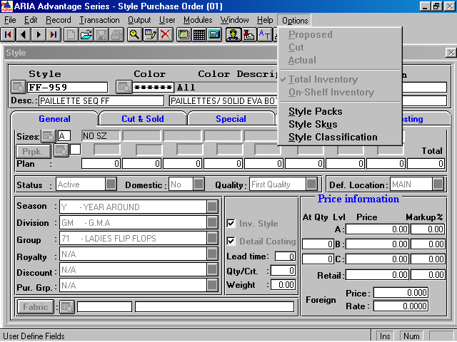
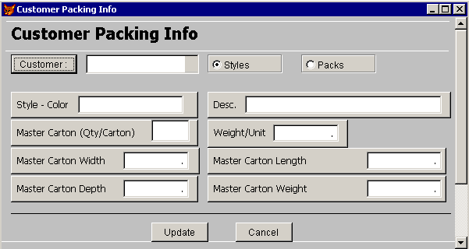
Customer Packing Info Screen:

Screen Rules:

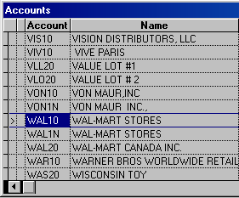
- Customer button will open a browse list with all the customers allowing the user to search and select one or more customer(s) to update the information for.

- Multiple selection will be allowed in this browse

- Styles/Packs option button will let the user decide if he wants to enter the Carton info for a Style/Color or a Pack Id. It’ll default to Styles and populate the current style/color code. If the user switched to Packs, the Style-Color text box will then be changed to browse the available Pack Id’s for this customer only.

- Style – Color will populate the current selected style/color record by default. If no color selected in the Style screen (Color field shows **** in Style screen), then changes will apply to all colors belonging to this style. If the user switched the Styles/Packs button to “Packs”, then the text box label will be Pack Id and allow to browse for this customer’s Pack Id’s/Color/Size/Version (please refer to our customizations in the Pack Maintenance screen).

- Master Carton (Qty/Carton) is the pre-defined quantity to be packed in each carton. In case of Packs, this field will represent the number of packs (inner Packs) that will be packed in one carton.

- Weight/Unit field will populate by default from the Style record (Style.Nstyweight) field for the current Style/Color record. The user will be allowed to edit it on each Customer record. In case of Pack Id, this field will calculate based on the qty of styles included in this pack Id (from Spck_lin file) multiplied by the unit weight for each style included.

- Master Carton Weight: is calculated based on: Qty/Carton multiplied by Weight/Unit.

- Master Carton Width, Depth, Length are numeric fields entered by user to specify the carton dimensions. They’ll populate by default from the user fields on the style record if any.

These info will be saved on the Customer + Style/Color level or
Customer + Pack Id/Color/Size/Version level in a new database. It’ll carry over to the sales orders belonging to this customer and including this style/color or Pack Id as will be explained in the following paragraph.

Note: we had these fields added as user fields from before on the Style file. The fields on this screen will populate by default from the user fields saved on the style level and then the user can modify them if he wants.

Create Packing List Template:

In this step, the user will be allowed to design a Packing List template on the sales order level to use this template to generate the Packing List automatically for each store in the selected order. The packing info (Qty/Ctn. and Unit Weight) will carry over to this template from the previously defined Packing Info on the customer level.

Screen Flow Chart:

Select Account/ Sales Order #

Details:
Select Styles

Carton Information

Generate P/L #

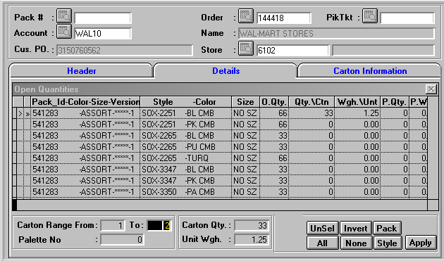
Packing List Template, Details:

Packing List Template:
Carton#

Screen Rules:

- The screen will allow the user to select an Account and/or Order #. Once a sales order is selected, the screen will collect and view all the styles in this sales order. The styles will be consolidated for all the stores in the order and sorted by: Pack_Id + Style/color + Size
- O.Qty column will display the total qty ordered/picked from this style/color/size consolidated for all the stores within the order #.
- Qty/Ctn and Wgh./Unt columns will be populated by default from the previously defined Customer Packing Info table per customer/style (Qty/Carton and Weight/Unit). In case of Pack Id exist in the order line, the Qty/Crt will be detailed by each style in the Pack Id and based on qty in Spck_lin file. However, the user should be allowed to edit these 2 fields on the order level in case there is no previously saved packing info.
- A validation will be done to make sure that the O.Qty is divisible evenly by the Qty/Ctn. If not, a warning message should popup to notify the user.

- Style button will select all the lines belong to the selected style major (different colors or sizes). The user can select more than one style in the same carton.
- Pack button will select all the lines belong to the selected Pack Id (if not empty).
- User will be able to Select/Unselect any line individually just by clicking on this line. If Pack Id, all the lines belonging to the same Pack Id should be selected.
- Apply button will collect all the selected lines (styles or packs) and put it in the current Carton #. A validation should be done to make sure that Qty/Ctn and Wgh./Unt are not zero. If any of them is zero, a warning message will popup preventing the user from applying the carton unless he fills the required data.

- Carton# column will show the carton # that the style has been applied into.

- Styles that were applied already in cartons will be disabled and grayed out.

- The Carton # will be generated sequentially after each time the user clicks on Apply button. However, the range of cartons will be calculated later on at the time of generating the P/L and based on the ordered/picked qty for each store as will be explained later.

Notes:

This Template info will be saved in a new database on the order level. The tables’ structure may be similar to the Packing List tables (Pack_hdr and Pack_lin).

Packing List Template, Carton Info:

The Carton Information tab will just display the carton’s pattern that the user applied. Two ways of viewing the Carton info will be available to switch between:
- Summary: will show only the Cartons. The Tot.Pcs and Tot. Wgh columns will consolidate the qty and weight per carton.

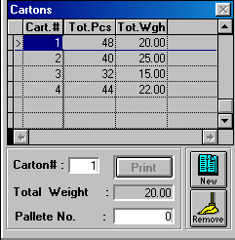

- Details: will show the Contents of Carton by style. Qty and Wgh. columns are for each style in this case.

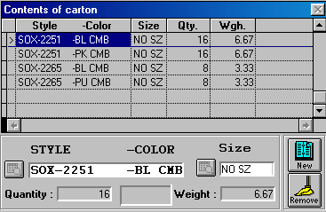
Carton#

If the user come back later and select the same order #, the previously saved Carton info will show up allowing the user to do any modifications to the Carton component as long as there are no Packing List generated yet for the order. Once the Packing Lists are generated, no changes will be allowed to this template info.

Generate Automatic Packing List:

In this screen, the program will recall the previously saved P/L template, allowing the user to inquire it, and use this template to generate the Packing Lists for the selected stores in the order. If no Template records exist for the selected order#, the screen should reject and give a message to indicate this to the user.

Select
Sales Order
Carton Information
Generate Packing List
Style Details
Select Stores

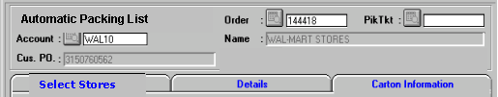
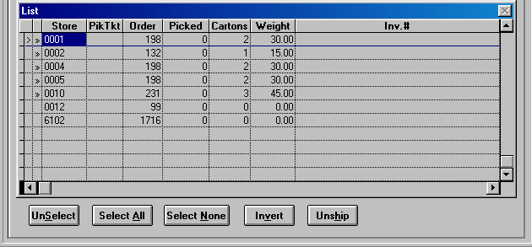
P/L #
BOL
P.Qty

D.C.#

- All the stores within the selected order will show up in this list. The user will be able to Select/UnSelect individual stores or Select All stores. The stores will be sorted in this list by: D.C. + Store #. The DC (Distribution Center) is linked to the store record usually in the Customer file (Customer.Dist_ctr).
- Pik Tkt column will show the Pick Ticket #, if any, generated for each store.
- Order column will show the total Qty ordered for each store.
- Picked column will show the total Qty picked for each store (if there is Pick Ticket created for this store).
Buttons and Functionality:

- Generate P/L:

When the user clicks the Gen. P/L button, the program will start create a separate Packing List # for each store in the order and assign the Qty into cartons based on the previously saved template.

Following rules and considerations will be taken:

- P/L # column will show the generated Packing List # for the corresponding store.
- Cartons column will show total cartons generated for the corresponding P/L. the program will calculate the range of cartons for each store/style based on the ordered qty for this store and the Qty/Crt specified previously in the template.
- Weight column will show total weight for corresponding P/L. the program will calculate the weight for each carton based on the ordered qty for this store and the Wgh/Unt specified in the template.
- A message should popup at the end of the process to indicate the range of P/L numbers generated.
- If the total Packed qty doesn’t equal the total Ordered qty, a warning message will show up to indicate that to the user.

Note: Assigning the P/L to the Bill of Lading will be done after generating the Packing Lists and through the Bill of Lading screen in the EDI module.

- Template

This button will view the Packing List Template screen for the selected order. User can inquire the existing P/L template without doing changes to it.

- Carton Information

It’ll show the Carton details for each store. Once the user selects a store, he can click on Carton Information tab to see the contents of the cartons generated for this specific store.
